🎯 Objective
To rigorously investigate the true impact, reliability, and limitations of feature selection techniques on machine learning performance, generalization, and interpretability.

Datasets Used

- The Breast Cancer Wisconsin Dataset (https://www.kaggle.com/code/abdulrhmansalama/breast-cancer-wisconsin-dataset/notebook) is a widely used biomedical classification dataset in machine learning for predicting whether a breast tumor is:
- Benign (non-cancerous):0
- Malignant (cancerous) :1
based on measurements extracted from breast cell images. It has 33 features and 569 row values.

- The Fetal health classification Dataset (https://www.kaggle.com/datasets/andrewmvd/fetal-health-classification?utm_source=chatgpt.com). This dataset contains 2126 records of 22 features extracted from Cardiotocogram exams, which were then classified by three expert obstetritians into 3 classes, Normal, Suspect, Pathological.

Correlation matrix of Dataset1
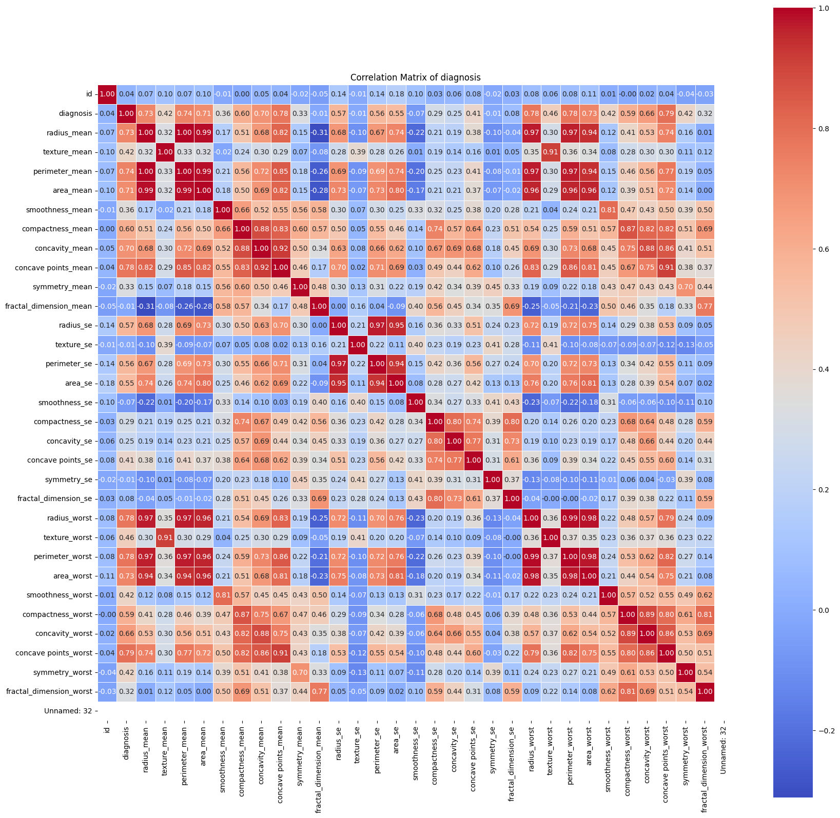

The above figure indicates that it has highly correlated features.

Value counts of target Variable: “Diagnosis”

- Benign: 357
- Malignant: 212

Baseline Model Performance Analysis (Before Feature Selection)
The performance of two machine learning models, namely Gaussian Naive Bayes and Random Forest, was evaluated on the Breast Cancer Wisconsin Dataset before applying feature selection techniques. The objective of this baseline experiment was to understand the inherent predictive capability of the models using all available features.
The dataset was divided into training and testing subsets using an 80:20 ratio, and Stratified 5-Fold Cross Validation was employed to maintain class balance during training. Performance evaluation was conducted using accuracy, precision, recall, and F1-score.

Baseline Performance of Models

Using Filter method: CORRELATION FEATURE SELECTION, 20 features are selected.

Model | Feature Selection | Mean CV Accuracy | CV Standard Deviation | Test Accuracy | ROC-AUC Score | Training Time (sec)
Random Forest | Before FS | 0.9626 | 0.0149 | 0.9649 | 0.9942 | 0.47
Random Forest | After FS | 0.9560 | 0.0120 | 0.9474 | 0.9922 | 0.48
Naive Bayes | Before FS | 0.9341 | 0.0256 | 0.9211 | 0.9891 | 0.01
Naive Bayes | After FS | 0.9099 | 0.0350 | 0.8947 | 0.9597 | 0.02

Model | Feature Selection | Precision | Recall | F1-Score | Accuracy
Random Forest | Before FS | 0.97 | 0.95 | 0.96 | 0.96
Random Forest | After FS | 0.95 | 0.93 | 0.94 | 0.95
Naive Bayes | Before FS | 0.92 | 0.91 | 0.91 | 0.92
Naive Bayes | After FS | 0.89 | 0.88 | 0.88 | 0.89

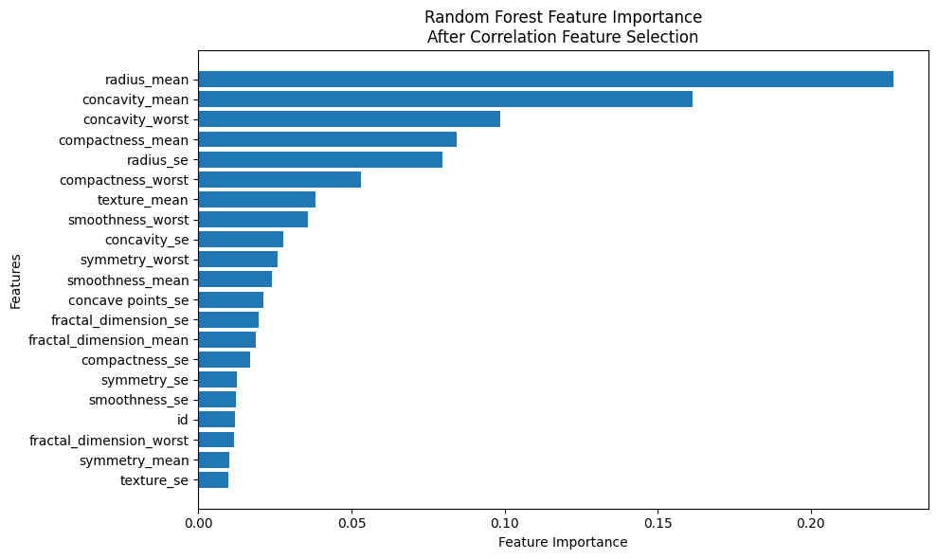
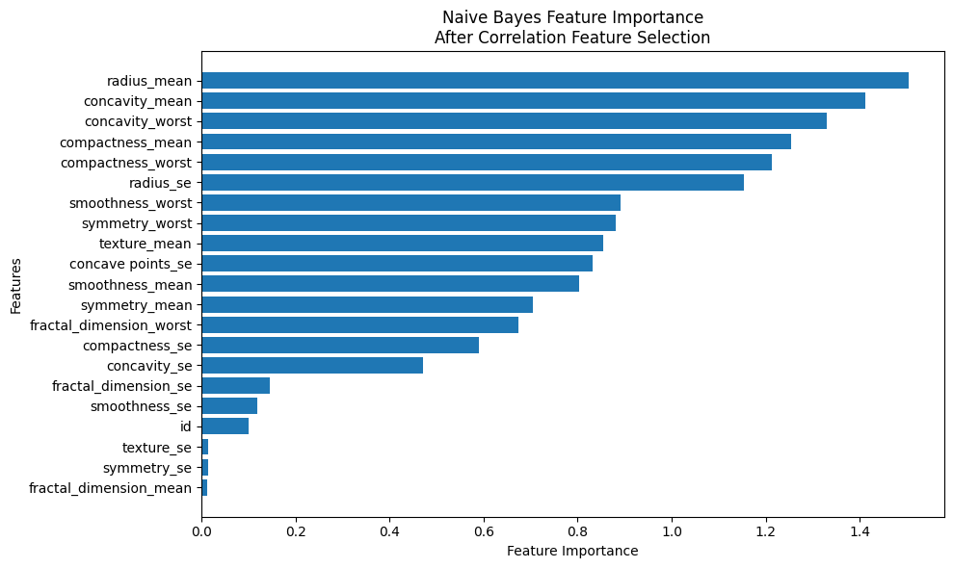

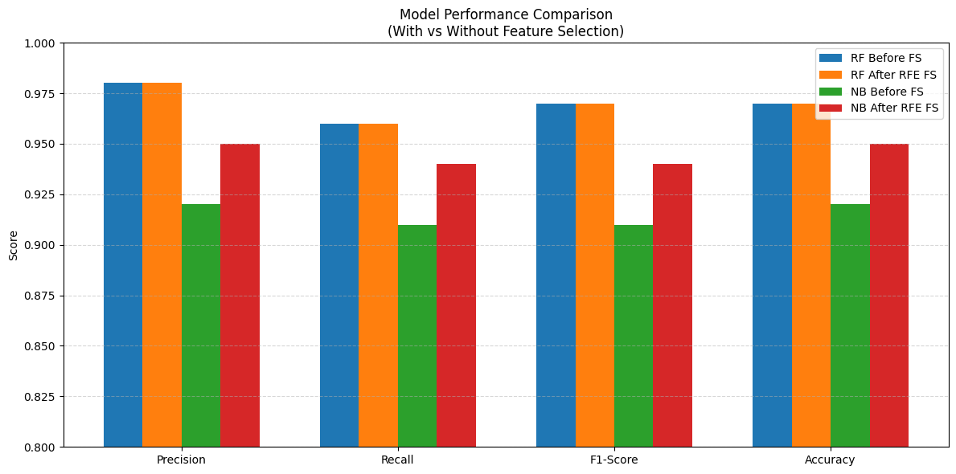

Using Wrapper method: RFE (Recursive Feature Elimination), 10 features are selected.

Model | Feature Selection | Mean CV Accuracy | CV Standard Deviation | Test Accuracy | ROC-AUC Score | Training Time (sec)
Random Forest | Before FS | 0.9626 | 0.0149 | 0.9649 | 0.9942 | 0.47
Random Forest | After RFE FS | 0.9582 | 0.0329 | 0.9737 | 0.9949 | 4.37
Naive Bayes | Before FS | 0.9341 | 0.0256 | 0.9211 | 0.9891 | 0.01
Naive Bayes | After RFE FS | 0.9429 | 0.0213 | 0.9474 | 0.9927 | 3.99

Model | Feature Selection | Precision | Recall | F1-Score | Accuracy
Random Forest | Before FS | 0.97 | 0.95 | 0.96 | 0.96
Random Forest | After RFE FS | 0.98 | 0.96 | 0.97 | 0.97
Naive Bayes | Before FS | 0.92 | 0.91 | 0.91 | 0.92
Naive Bayes | After RFE FS | 0.95 | 0.94 | 0.94 | 0.95

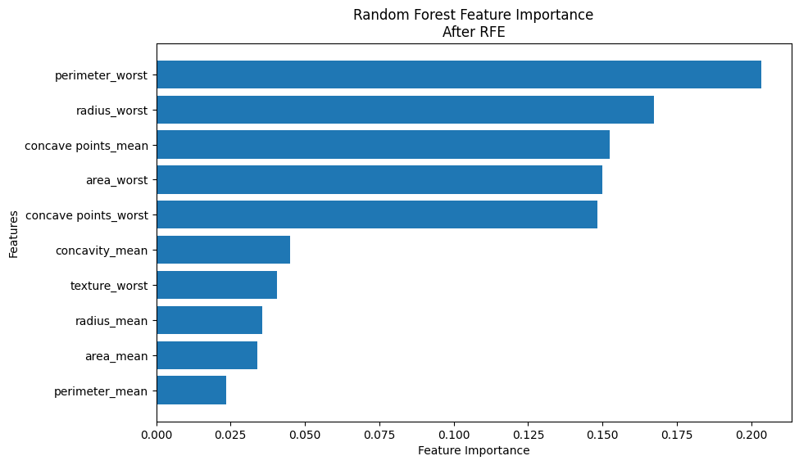

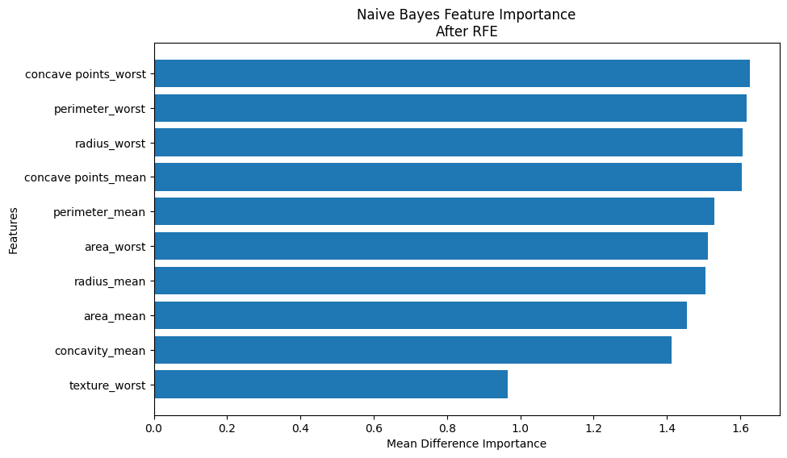

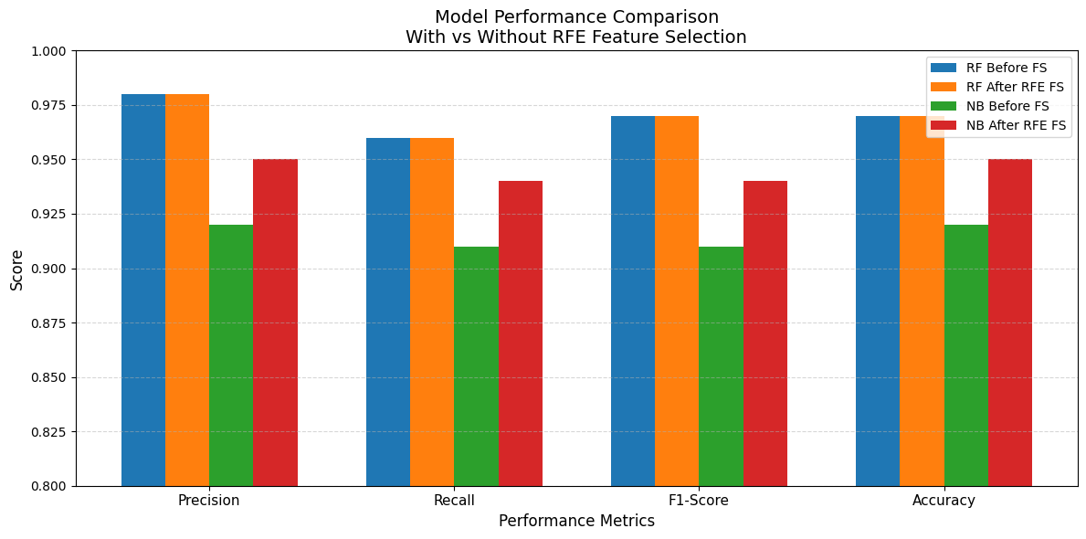

Using Embedded method: L1 (Lasso), 7 features are selected.

Model | Feature Selection | Mean CV Accuracy | CV Standard Deviation | Test Accuracy | ROC-AUC Score | Training Time (sec)
Random Forest | Before FS | 0.9626 | 0.0149 | 0.9649 | 0.9942 | 0.47
Random Forest | After LASSO FS | 0.9692 | 0.0213 | 0.9649 | 0.9950 | 0.48
Naive Bayes | Before FS | 0.9341 | 0.0256 | 0.9211 | 0.9891 | 0.01
Naive Bayes | After LASSO FS | 0.9495 | 0.0275 | 0.9386 | 0.9924 | 0.01

Model | Feature Selection | Precision | Recall | F1-Score | Accuracy
Random Forest | Before FS | 0.97 | 0.95 | 0.96 | 0.96
Random Forest | After LASSO FS | 0.97 | 0.95 | 0.96 | 0.96
Naive Bayes | Before FS | 0.92 | 0.91 | 0.91 | 0.92
Naive Bayes | After LASSO FS | 0.94 | 0.93 | 0.93 | 0.94

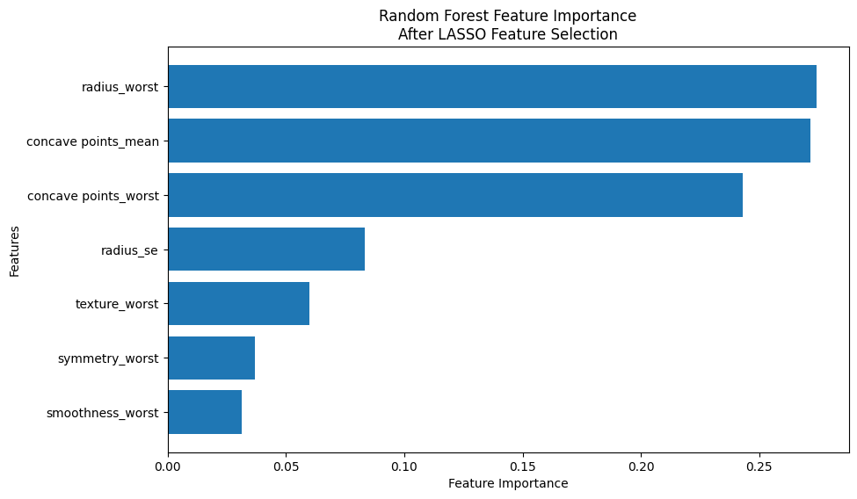

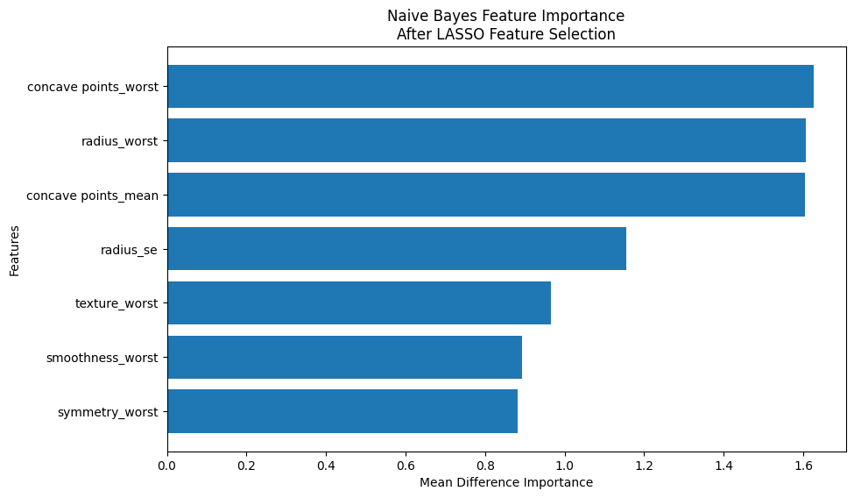
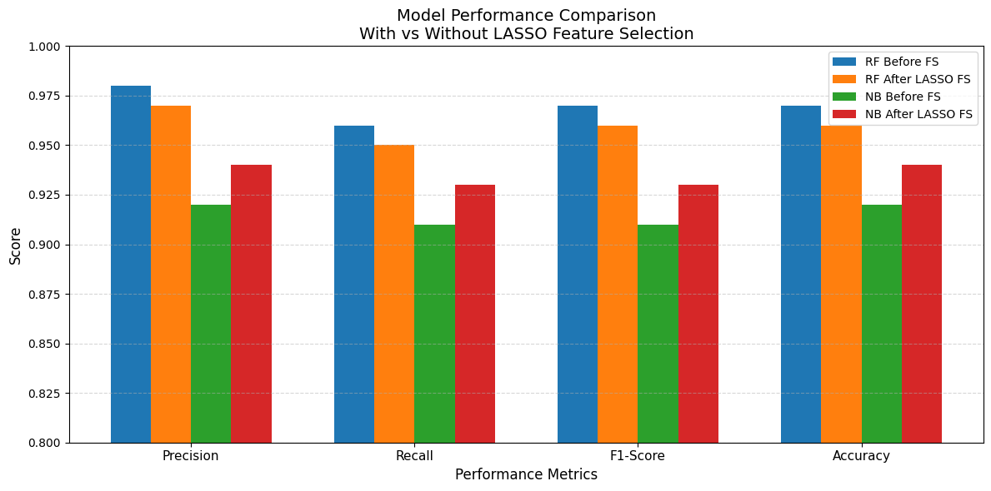Feature Selection Comparative Analysis Report
Phase 1: Baseline and Correlation Feature Selection Analysis
The baseline performance analysis was conducted using all available features from the Breast Cancer Wisconsin Dataset to evaluate the predictive capability of Random Forest and Gaussian Naive Bayes models before applying feature selection techniques. Random Forest achieved a test accuracy of 0.9649 with a ROC-AUC score of 0.9942, while Naive Bayes achieved an accuracy of 0.9211 with a ROC-AUC score of 0.9891. After applying correlation-based feature selection, which retained 20 selected features by removing highly correlated variables, the performance of both models decreased slightly. Random Forest accuracy reduced from 0.96 to 0.95, and Naive Bayes accuracy reduced from 0.92 to 0.89. Similarly, precision, recall, and F1-score also decreased after feature selection. These findings indicate that although correlation feature selection successfully reduced redundancy, some removed features still contained valuable predictive information.
Phase 2: RFE (Recursive Feature Elimination) Analysis
Recursive Feature Elimination (RFE) was implemented as a wrapper-based feature selection technique using Random Forest as the estimator. RFE selected the top 10 most relevant features from the dataset. After applying RFE, the Random Forest classifier showed improved performance, where test accuracy increased from 0.9649 to 0.9737 and ROC-AUC score improved from 0.9942 to 0.9949. Precision, recall, and F1-score also improved slightly from 0.97, 0.95, and 0.96 to 0.98, 0.96, and 0.97 respectively. The Naive Bayes classifier demonstrated even greater improvement, with test accuracy increasing from 0.9211 to 0.9474 and ROC-AUC score increasing from 0.9891 to 0.9927. These results suggest that RFE effectively identified the most informative variables while eliminating irrelevant and noisy features, thereby improving model generalization and predictive performance.
Phase 3: LASSO Feature Selection Analysis
LASSO feature selection was applied using L1 regularization to select the most important predictors from the dataset. The method selected 7 significant features, thereby reducing dimensionality considerably. After applying LASSO, the Random Forest model maintained almost identical performance compared to the baseline model, achieving a test accuracy of 0.9649 and ROC-AUC score of 0.9950. Precision, recall, and F1-score remained stable at 0.97, 0.95, and 0.96 respectively. The Naive Bayes model demonstrated clear improvement after LASSO feature selection, where accuracy increased from 0.9211 to 0.9386 and F1-score improved from 0.91 to 0.93. In addition, training time remained very low while the model became simpler and easier to interpret. These findings indicate that LASSO successfully removed less relevant variables while preserving the most discriminative features.
Phase 4: Performance Comparison
A comparative analysis of all feature selection techniques demonstrated that different methods influenced model performance in different ways. Correlation-based feature selection reduced the predictive performance of both Random Forest and Naive Bayes, indicating that some correlated variables still contributed useful information. RFE provided the best overall performance improvement, especially for the Naive Bayes classifier, which showed substantial increases in accuracy, precision, recall, and F1-score. LASSO achieved a strong balance between dimensionality reduction and predictive performance by maintaining high accuracy with only seven selected features. Overall, Random Forest consistently achieved higher classification performance than Naive Bayes across all experimental settings.
Phase 5: Deep Comparative Analysis
The deep comparative analysis revealed important insights regarding performance, generalization, stability, and trade-offs among feature selection techniques. RFE improved average performance while also reducing the gap between training and testing accuracy, indicating strong generalization capability. LASSO reduced model complexity and computational cost while maintaining competitive performance. In contrast, correlation-based feature selection caused performance degradation due to the removal of informative correlated variables. Overfitting and underfitting analyses showed that the models generalized well, as training and testing accuracies were closely aligned without significant variance. Stability analysis further suggested that RFE produced more consistent feature subsets across folds compared to simple correlation filtering. The trade-off analysis demonstrated that simpler models with fewer features can still maintain high predictive performance when important variables are carefully selected.
Phase 6: Visualization and Feature Importance Analysis
Visualization techniques such as correlation heatmap and feature importance plots were used. Feature importance analysis demonstrated that only a limited number of variables contributed significantly to prediction. In the Random Forest model, feature importance values were derived from tree-based importance measures, whereas for Naive Bayes, feature importance was estimated using absolute mean differences between classes. The visualizations supported the conclusion that RFE and LASSO successfully retained the most informative variables while eliminating redundant and less useful features.
Phase 7: Research Discussion and Conclusion
The study demonstrated that feature selection techniques can significantly influence machine learning performance, generalization, interpretability, and computational efficiency. Among the evaluated techniques, RFE emerged as the most effective and stable method, particularly improving Naive Bayes classification performance. LASSO also proved highly effective by reducing dimensionality while maintaining strong predictive capability. Correlation feature selection, although useful for reducing redundancy, may negatively affect performance when correlated features contain important predictive information. The findings also revealed that the usefulness of feature selection depends on the type of classifier being used. While robust ensemble models such as Random Forest can perform well even without aggressive feature reduction, simpler probabilistic models such as Naive Bayes benefit substantially from selecting the most relevant variables. Therefore, feature selection should be applied strategically based on the dataset characteristics and model requirements.

